Support Immigrants and Refugees!
After the recent attacks on immigrant and refugee communities at both the state and federal level, it is time to come together and lift up the voices of our communities! Our movement is about building the world we believe in, one that is welcoming, diverse, and inclusive. So let’s lift up that vision and demand that those in power follow our lead.

What can you do?
- Organize a press conference, rally, or other public event
- Visit, call, or send a postcard to your legislator(s) and say #StoptheHate
- Thank the Mayors of cities in PA who have stood up for immigrants & refugees
- Post your message on social media with the hashtags: #PAlovesImmigrants #RefugeesWelcome #StoptheHate
- Sign a petition supporting immigrants & refugees
- Donate to a local community organization
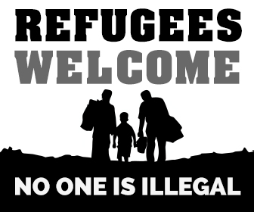
Go to www.paimmigrant.org for more information!

