#ShutDownBerks Video Series

Family Detention is immoral and unlawful. That is why we need Governor Wolf, Lt. Governor Fetterman and the PA Department of Human Services Secretary, Teresa Miller, to act NOW. They must issue an Emergency Removal Order on the Berks County Detention Center and convert the prison into an affordable and quality drug treatment facility

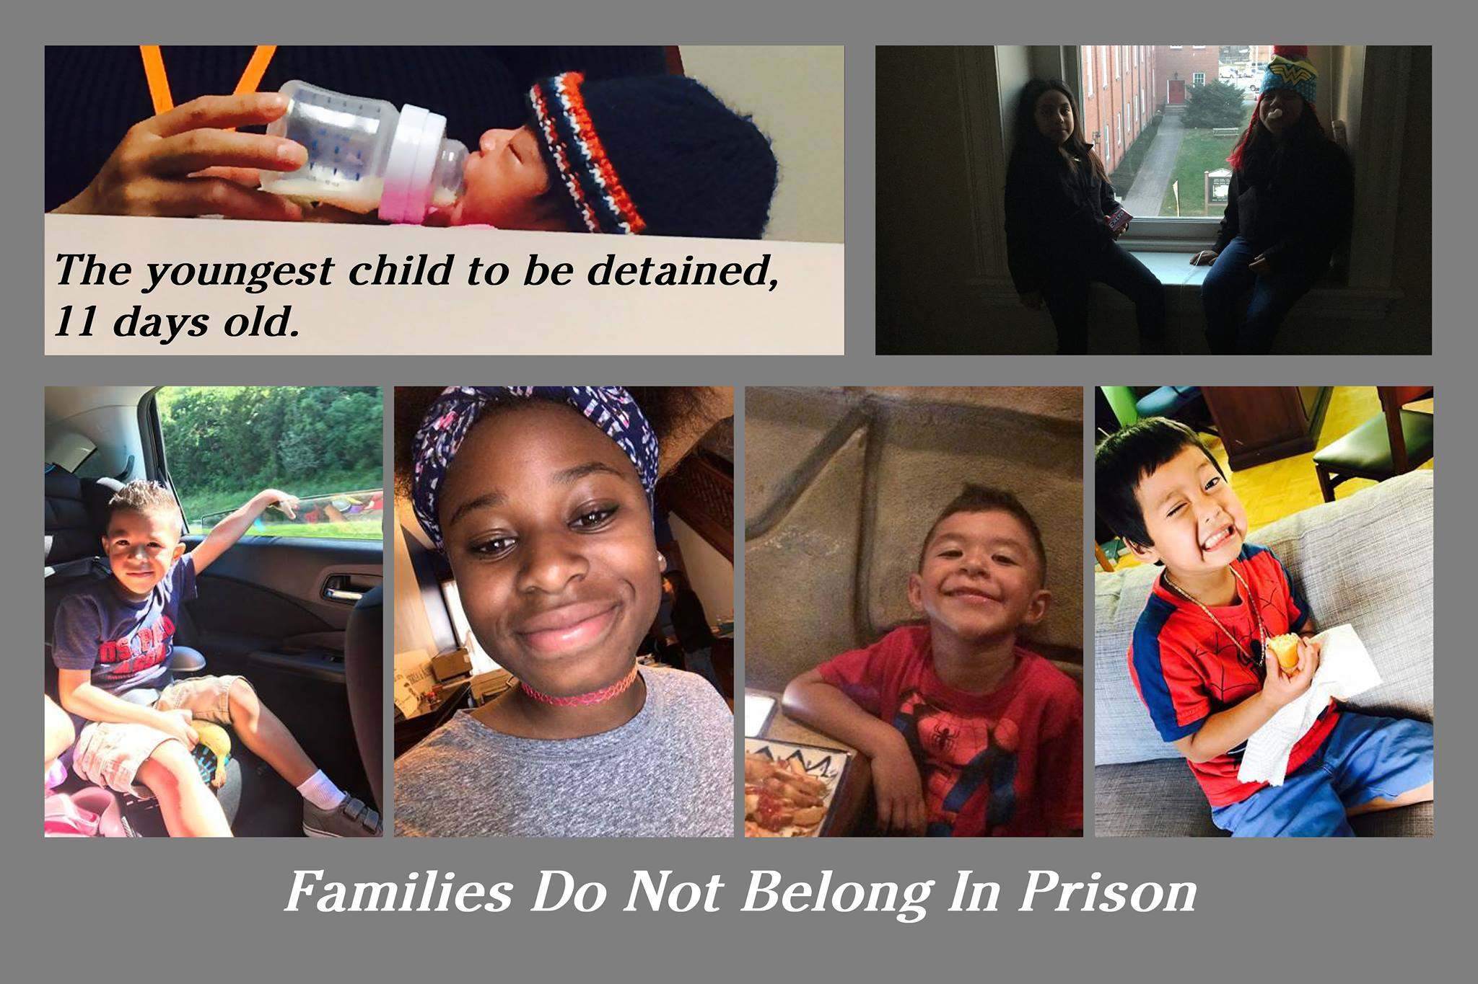
Listen to the Families themselves Families have been fighting back since this center opened, leading work and hunger strikes while detained. Here’s formerly detained parents sharing their messages to Governor Wolf.

- Mouhammad
- Sofia
- Lorena
- Delmy
- Father
- Victor
- Gladis

Learn about the campaign and how to shut it down. Check out the following video series to learn about the history of the center, the campaign and the legal grounds to end family detention in Pennsylvania. English and Spanish below.

#ShutDownBerks video 1: The mental and physical effects on children  #ShutDownBerks video 2: No family should bury their baby because they seeked refuge  #ShutDownBerks video 3: Frequently Asked Questions  #ShutDownBerks video 4: Pennsylvania Has The Power To Issue An Emergency Removal Order  #ShutDownBerks video 5: The Opioid Epidemic in Berks County  #ShutDownBerks video 6: No Family Separation, Detention or Deportations | #ShutDownBerks video 1: Los efectos mentales y físicos en los niños  #ShutDownBerks video 2: ninguna familia debe enterrar a su bebé porque buscaron refugio  #ShutDownBerks video 3: Preguntas más frecuentes  #ShutDownBerks video 4: Pennsylvania Tiene El Poder De Emitir Una Orden De Emergencia  #ShutDownBerks video 5: La epidemia de opioides en el condado de Berks  #ShutDownBerks video 6: No separación familiar, detención o deportaciones

